**TCC User Guide**

1.Log In

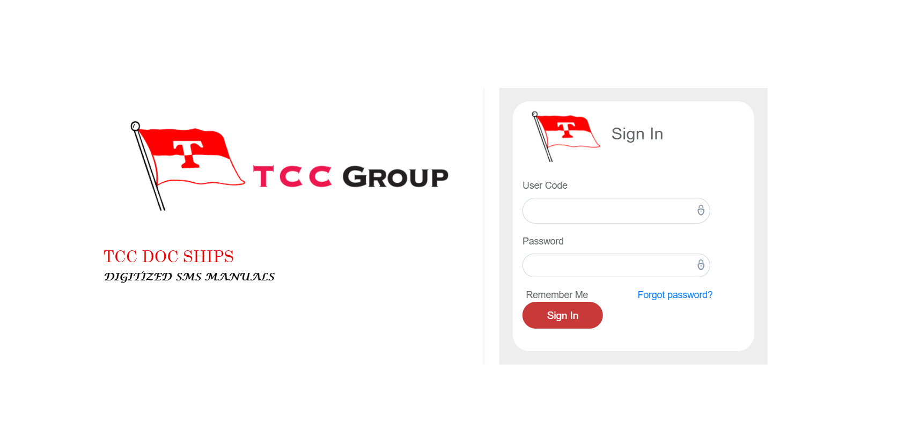

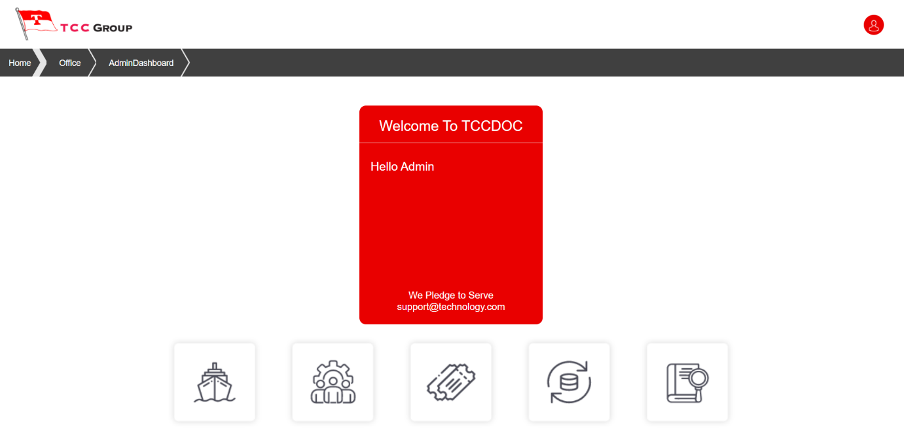A. This is the Log in Page. Here you have to log in by giving the admin ID and Password.

B. This is the admin dashboard window above which will appear after logging in.

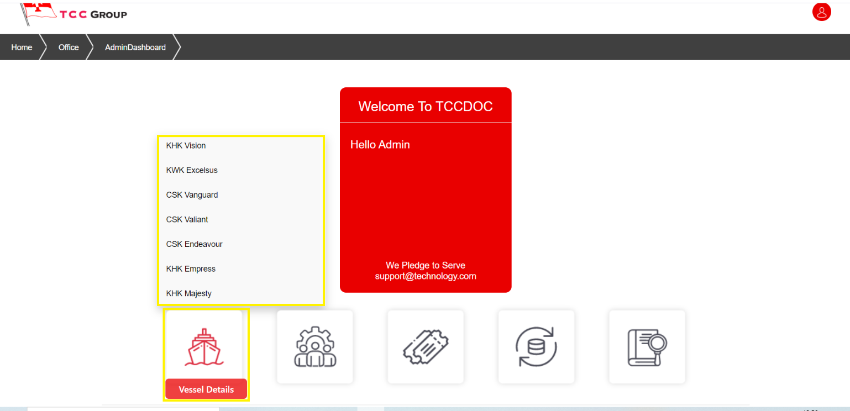2.Vessel Details

A. By moving the cursor over the vessel details button, it shows all the names of the ships mentioned here.

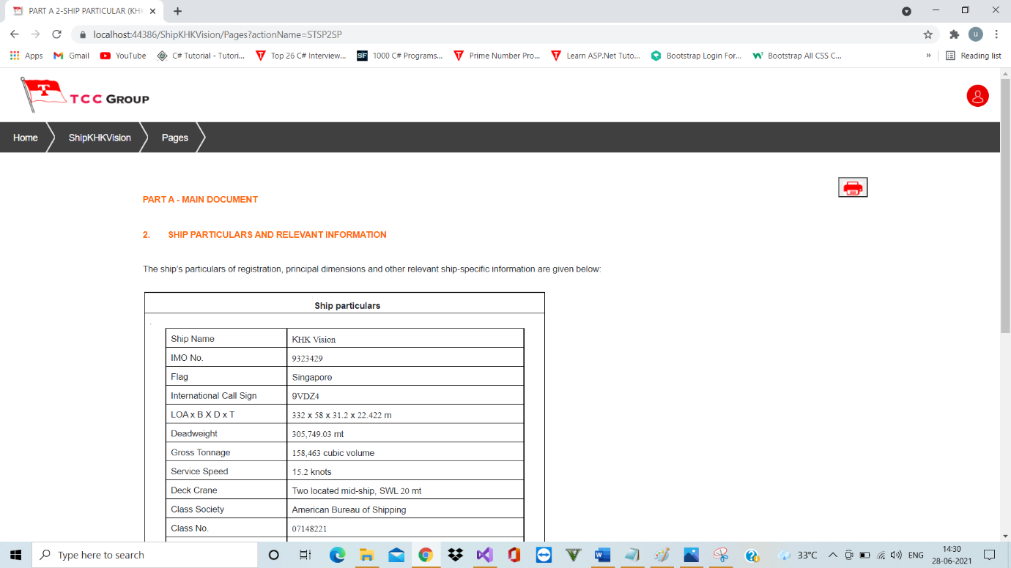1.KHK Vision

A. The above picture shows the details of ship KHK Vision particularly as it has been clicked from the ship menu and will show the same in particular for all ships when clicked individually.

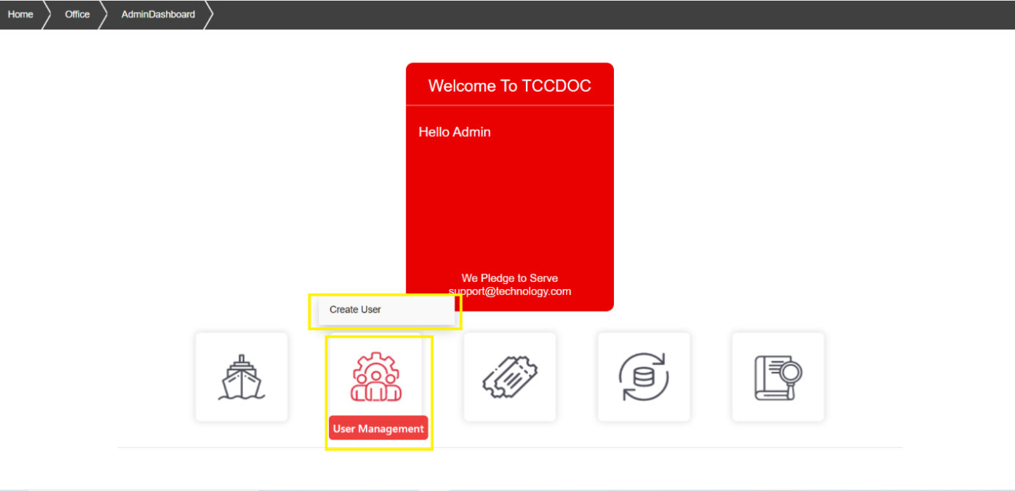3.User Management

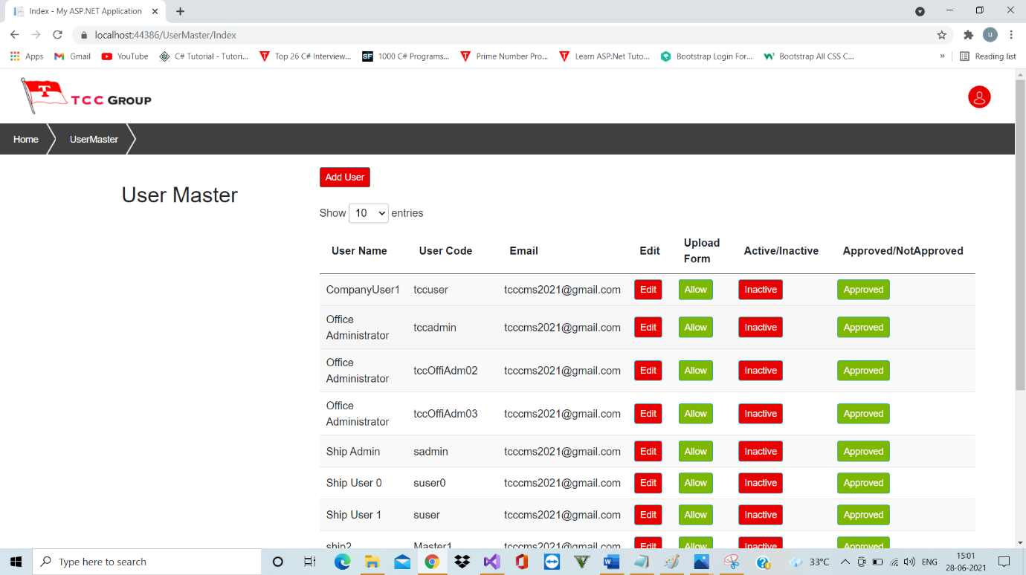A. By moving the cursor over the User Management, the create user button appears br which users can be created.

B. The above picture shows the list of users created.

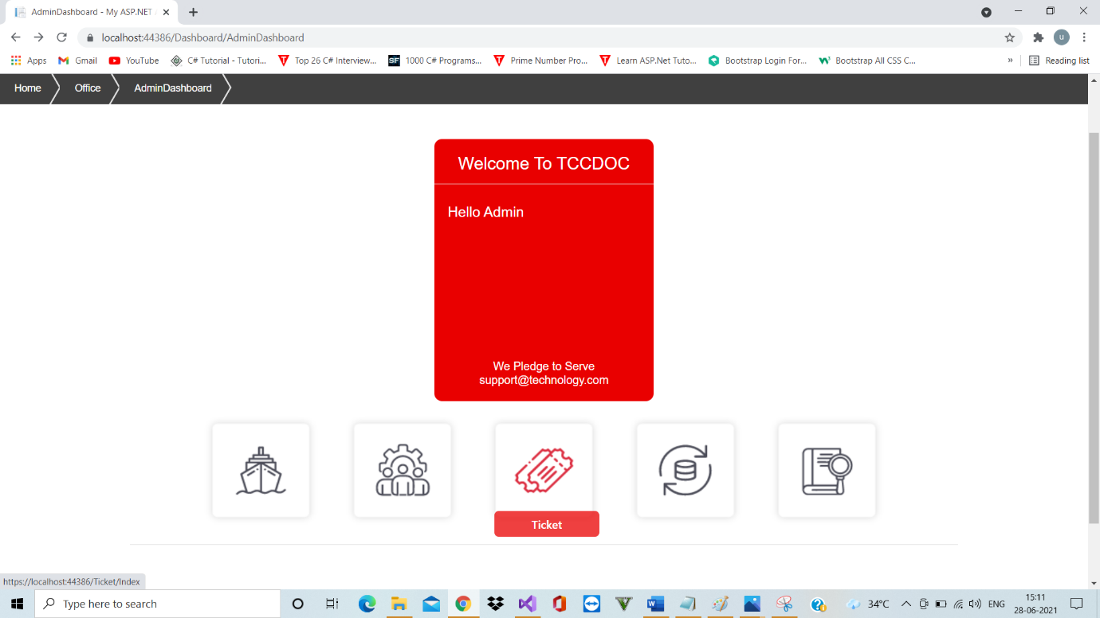4.Ticket

A.Ticket can be raised by clicking the ticket button.

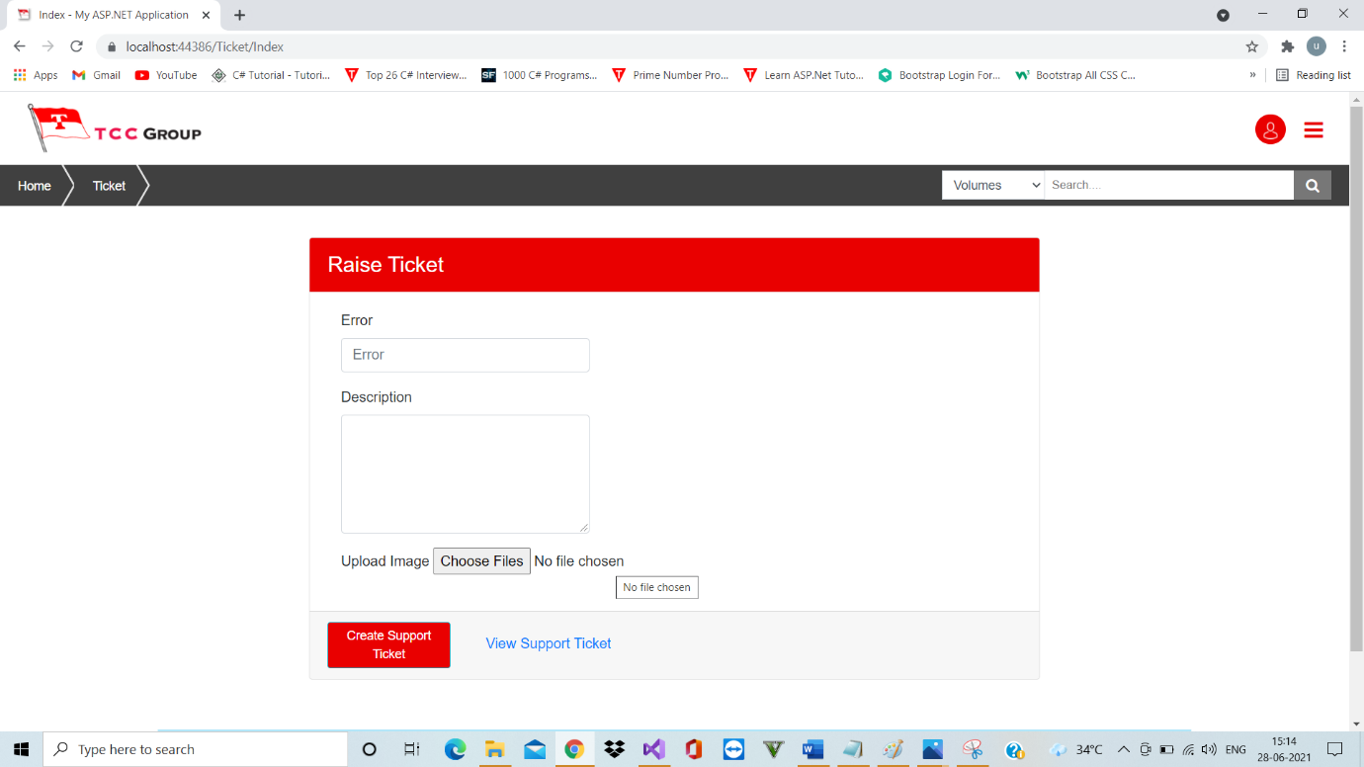

B. The above picture shows the Ticket window.

1.Log In

A. This is the Log in Page. Here you have to log in by giving the user ID and Password.

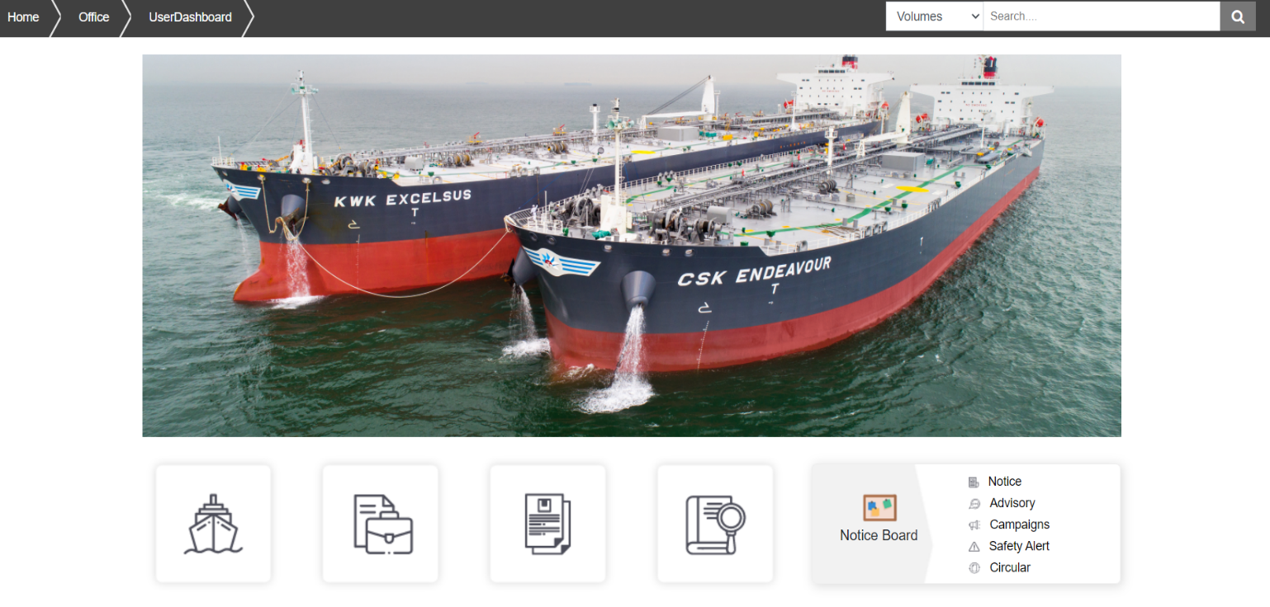

B. This is the user dashboard window above which will appear after logging in.

2.Ship Specific Manuals & Plans

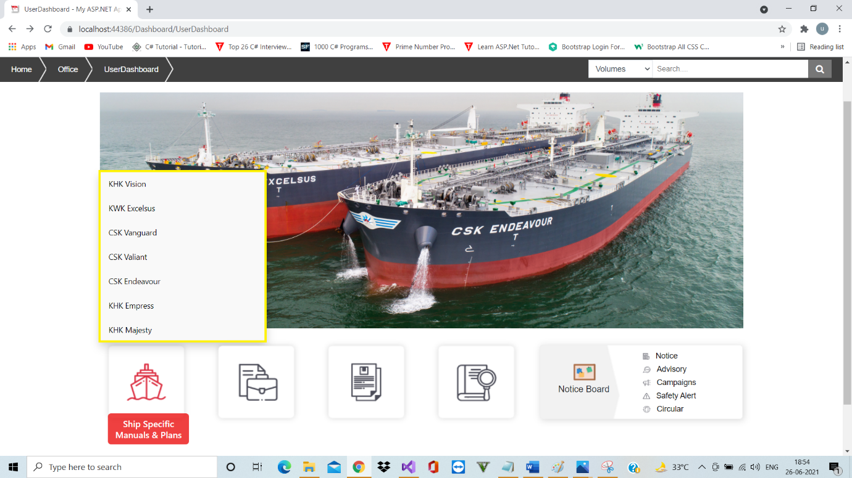

A. By moving the cursor over the ships specific manuals & plans button, it shows all the names of the ships mentioned here.

B. As it is been logged in by office user ID , it shows all the names. But if logged in by any particular ship ID ,it will show that particular ship name only.

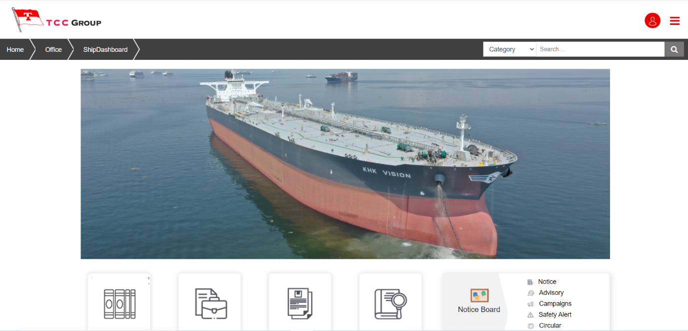1.KHK Vision

A. The above picture shows the KHK Vision ship dashboard.

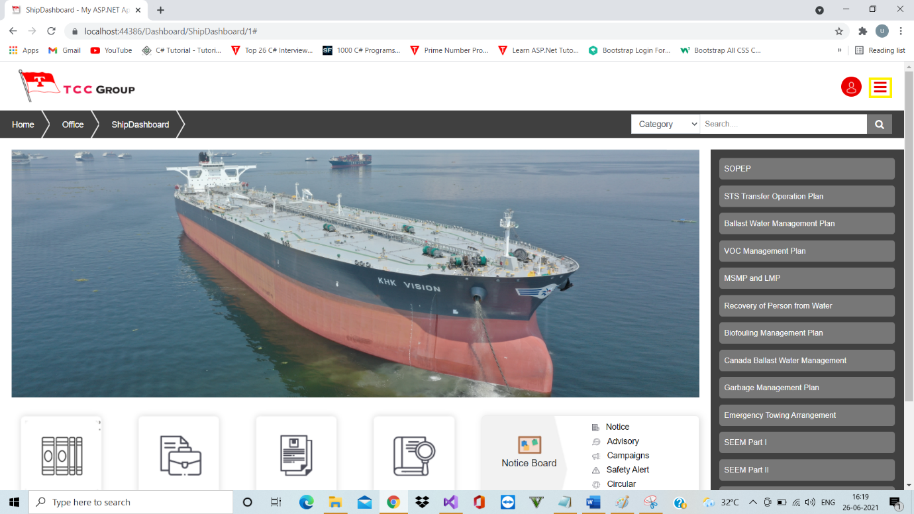

B. By clicking the button shown above [highlighted in yellow], the names list menu of ship on the right side will appear which is there inside the ship KHK Vision. And this is same for all ships.

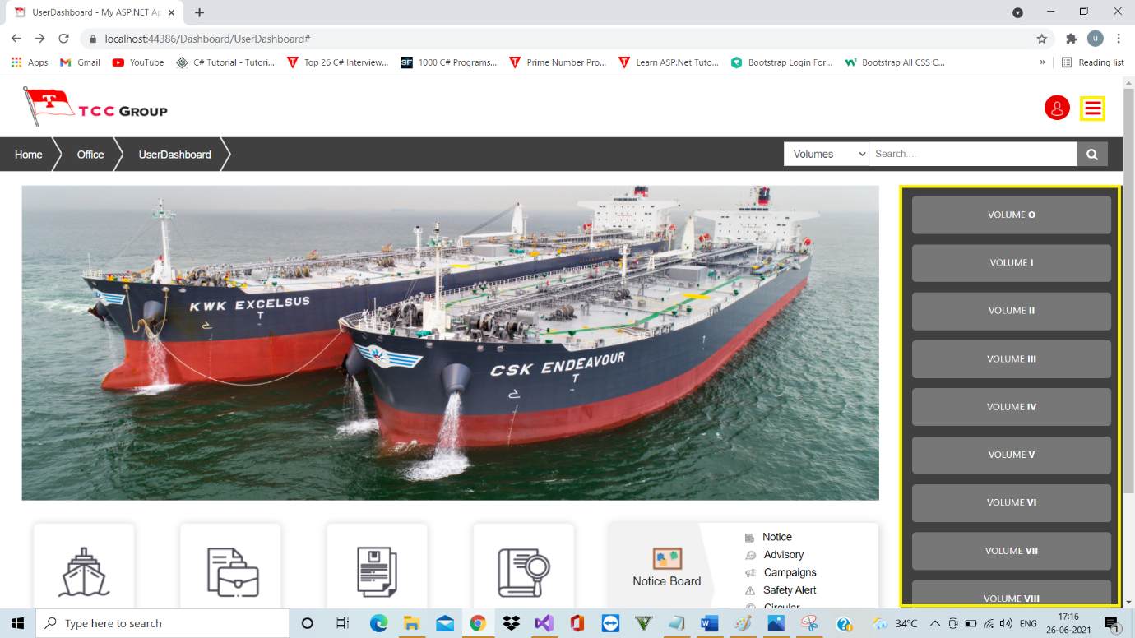3.Volumes

A. On the user dash board, by clicking on the button again shown above [highlighted in yellow], the names list menu of Volumes will appear on the right side.

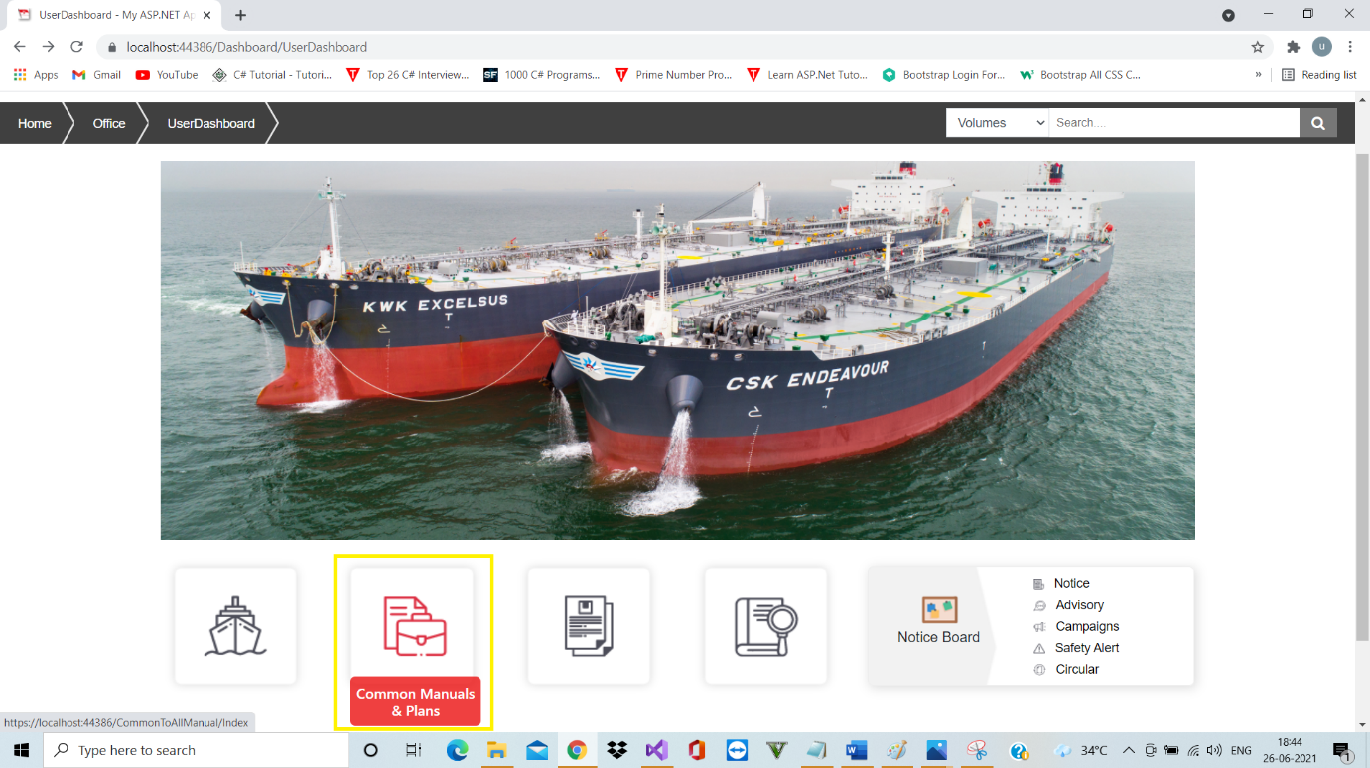4.Common Manuals & Plans

A. By Clicking the common manuals and plans button the Common To All Manual window will appear.

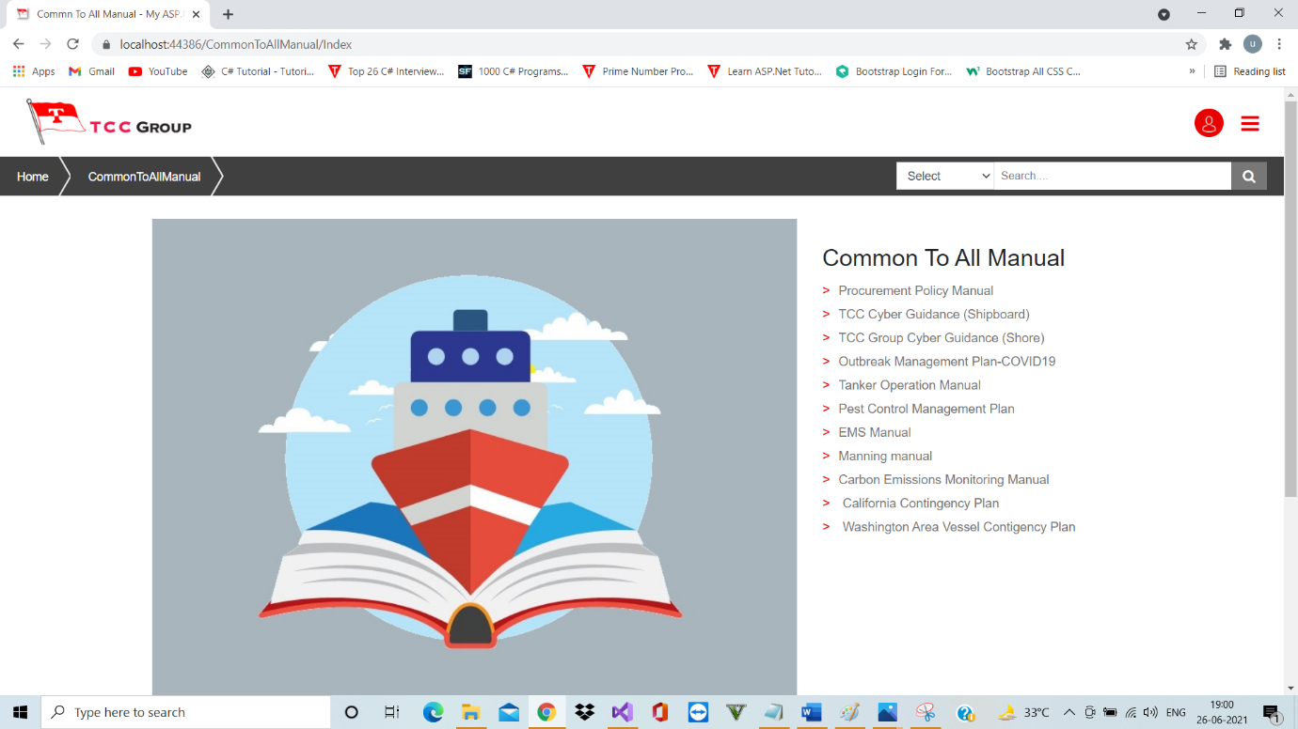

B. The picture above shows the Common To All Manual window.

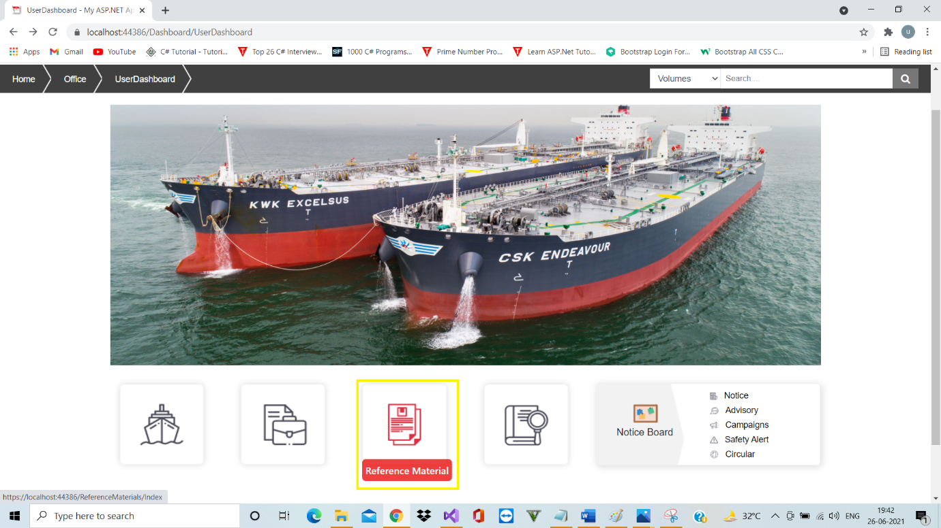5.Reference Material

A. By Clicking the reference material button the Reference Material window will appear.

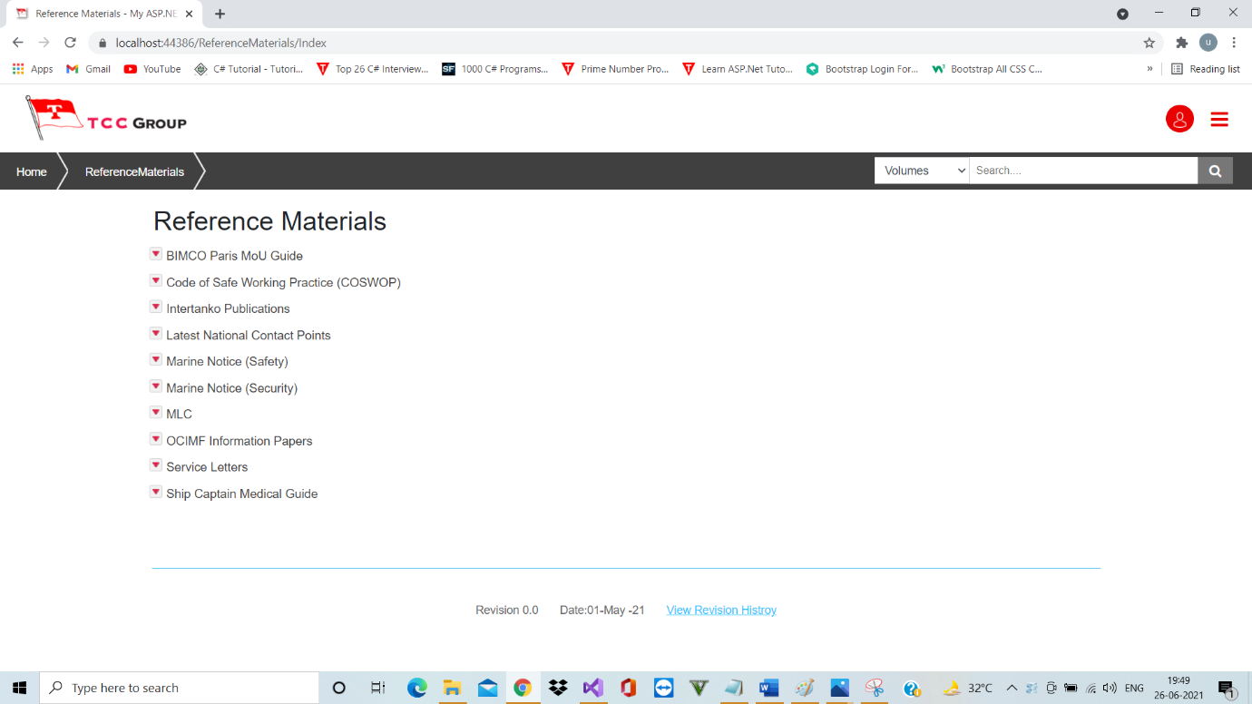

B.The picture above shows the Reference Materials window.

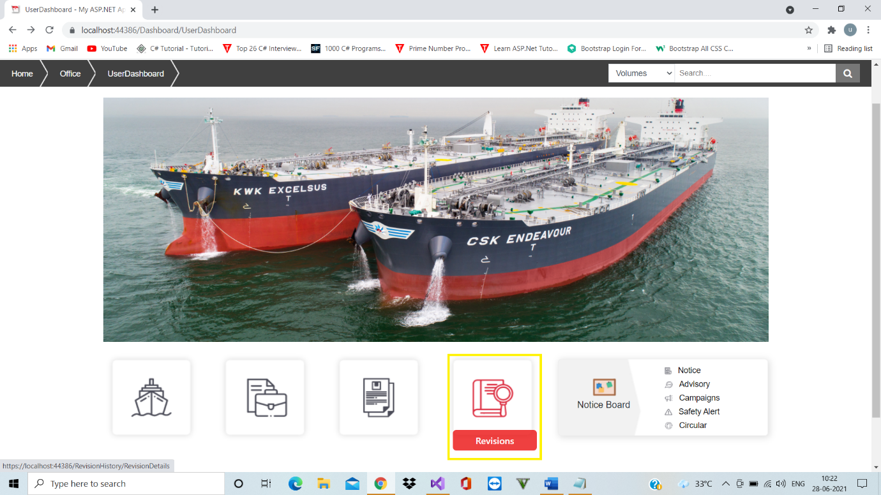6.Revisions

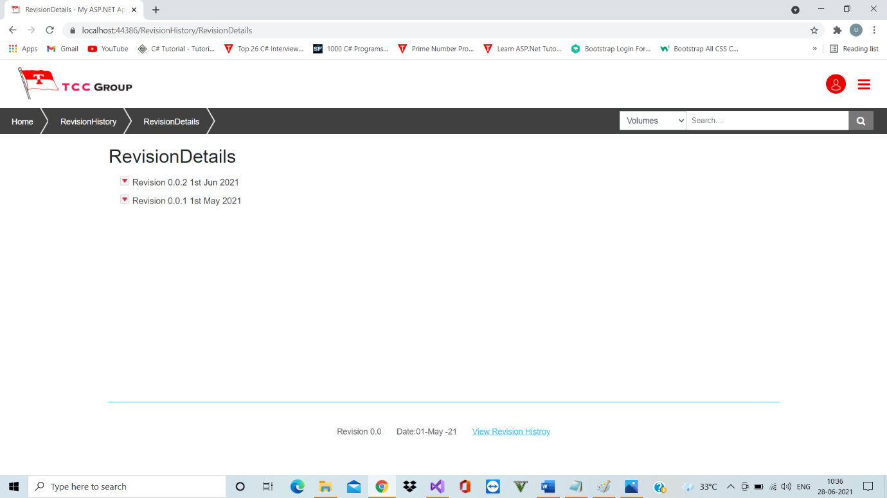A. By Clicking the revisions button the Revisions window will appear.

B. The picture above shows the Revision Details window.

C. The revisions done in the Admin is reflected in the revision details of the Office.

7.Notice Board

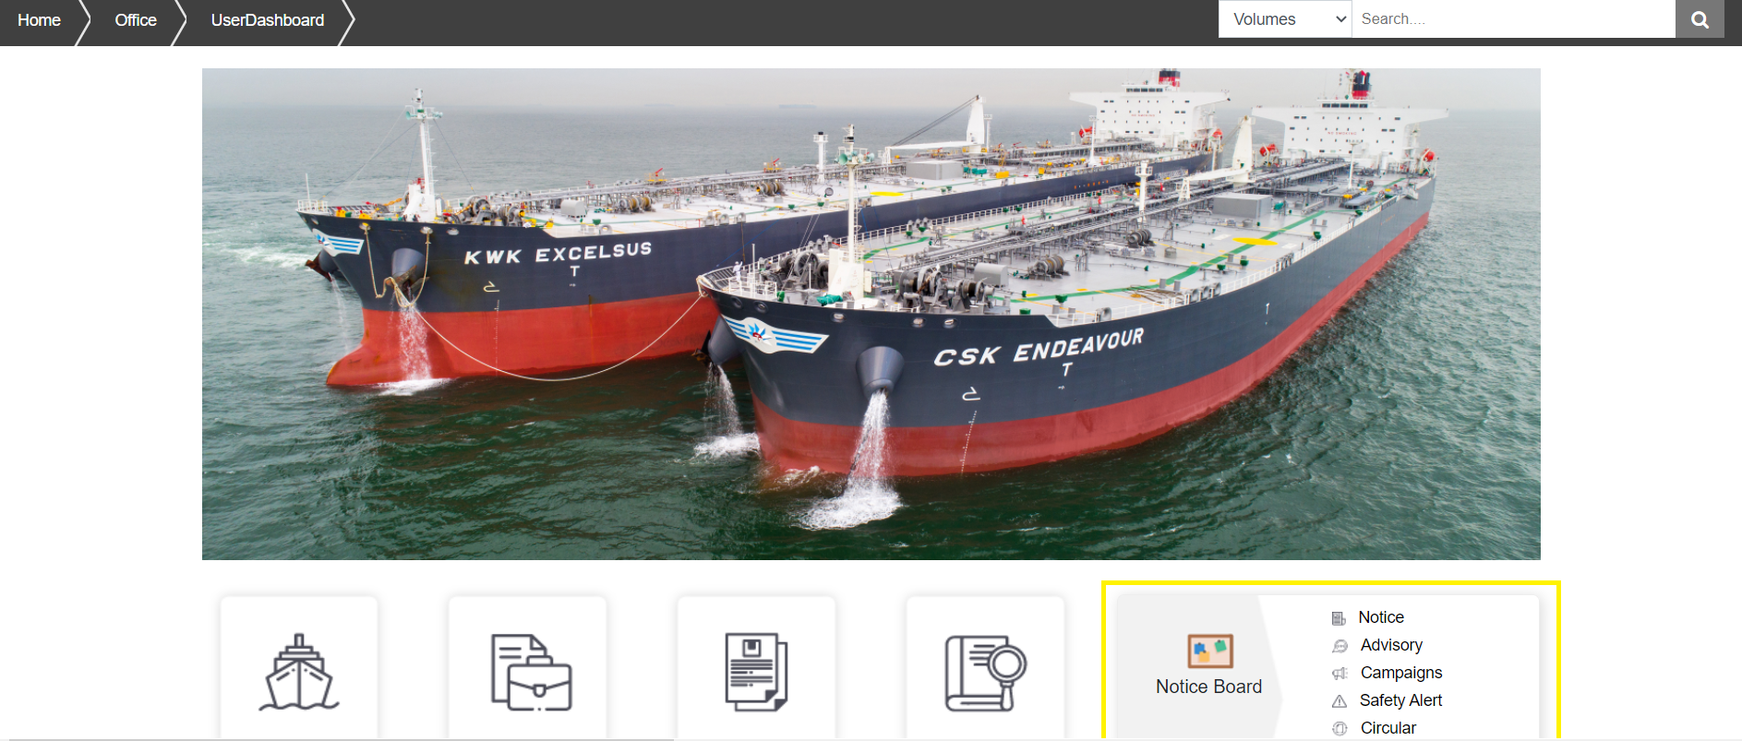

A. By Clicking a particular option of notice board button that particular option’s window will appear.

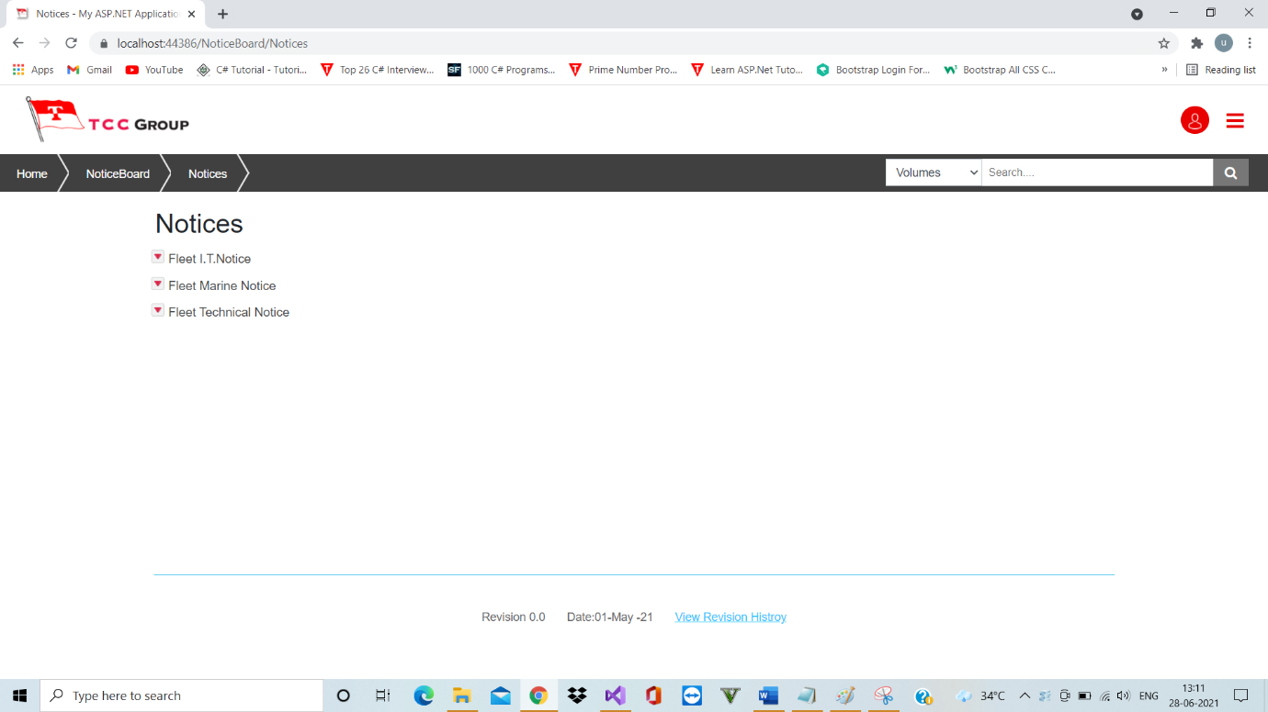

B. The picture above shows the Notices window of the Notice Board.